Prior Knowledge/Skills:  Geography: The children can name the 7 continents and can explain why certain places around the world are hot or cold.  History: The children have learnt about some events beyond living memory such as The gunpowder Plot and WW2.  Science: The children can name some materials and talk about their properties.  DT: The children have developed cooking skills such as peeling and chopping to make a fruit smoothie. They understand what it means to eat healthily. | New Knowledge/Skills:  Geography: The children will be able to name the capital city of the UK and learn about some of its characteristics. They will compare London to Clawton and discuss the similarities/differences.  History: The children will learn about The Great Fire of London and the changes that had to be made as a result of the fire. We will make links with the other events beyond living memory and how they affected community, knowledge and power.  Science: Children will now use their knowledge of materials to carry out an investigation and decide on the best materials to use for a given purpose.  DT: Children will now learn about the different food groups and what a ‘balanced meal’ is. They will design and make a healthy sandwich.
Key Texts:  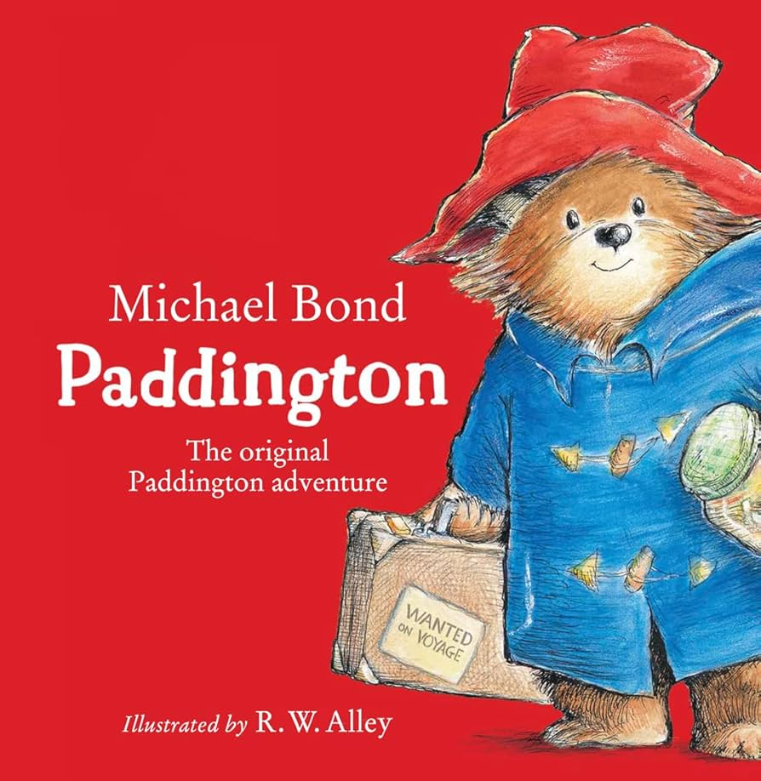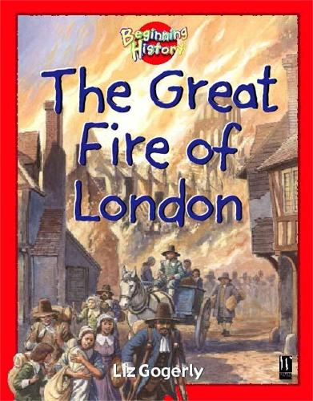 | Key Vocabulary:  continents, oceans, capital, city, bustling, flammable, raged, devoured, extinguished, possessions, merchant, ineffective, engulfed, doused, material, natural, human-made, recycle, smooth, rough, flexible, rigid, brittle, flexible, transparent, translucent, opaque, hard, shiny. dull, tough, lightweight, soft, bend, squash, twist, stretch, independent variable, dependent variable, controlled variable, waterproof, strong, breakable, balanced diet, food groups, carbohydrates, proteins, dairy, combination, design brief, evaluate, ingredients, review.
Wow Beginning:  Paddington arrives with his suitcase. Inside are some London souvenirs and a letter explaining that he has come to stay to teach them about the city he lives in. | Celebration:  Paddington movie night.
Elicitation Task:  London quiz. | Final Assessment:  Repeat the elicitation task.

The Learning Journey

SELF: WHO WE ARE
What is it like where Paddington lives?
Question - the knowledge and understanding you want the children to acquire. | Subject area - which subject/s will best answer this question? | Learning Intention  (Refer to subject specific skills progressions for annual coverage). | Lesson Content - what the children do during the lessons to develop the skill – what is produced at the end? | Assessment - next steps
Where in the world is the UK? | Geography | I can identify the four countries making up the United Kingdom.  I can name some of the main cities in the United Kingdom.  I can name the seas surrounding the United Kingdom. | Explore the world map. Pinpoint the 7 continents and 5 oceans. Watch the Oceans and Continents video on YouTube.  Look more closely at the UK. What are the 4 countries? What seas surround the UK? What is our capital city?  UK atlas work. Add the flags of the four different countries and London as the capital of England. This will be the first page in their London scrapbook.
Where is London and what is it like? | Geography  DT | I can name the capital city of England and find it on a map of the United Kingdom.  I can name some features identified with a city. | Look at Paddington’s presentation of London. What landmarks did you see?  Make models of famous landmarks in London to create a large city map. What are the buildings like?  How does London compare to Clawton? What are the main differences? Are there any similarities?
Why did some parts of London have to be rebuilt? What was The Great Fire of London? | History | I can talk about the events that happened during The Great Fire of London.  I know what changes were made in London as a result of the fire. | Follow CUSP History planning for Year 2: Events Beyond Living Memory: The Great Fire of London (6 sessions).
What is the weather like in London? What materials are best for a waterproof coat? | Geography  Science | I can name and describe the properties of different materials.  I can carry out an investigation to find waterproof materials. | Have a look at the weather forecast for London and explain that it's the same weather as we experience in Clawton. Look at our weather chart. How much rain have we had? Agree that Paddington’s coat isn't very waterproof and that we should design him a new one to take back with him.  Follow the White Rose Science Planning for Year 2: Materials. What materials would be best for a waterproof coat?
What sandwich would Paddington like for his journey home? | DT | I can name the different food groups.  I can design and make a healthy and tasty sandwich. | Follow the Kapow DY Planning for Year 2: Cooking and Nutrition.  Children make a sandwich for Paddington to take for his journey home.

