Prior Knowledge/Skills:  The children have located London on a map of the UK and learnt about life in a city. They have explored their surroundings and built models of well known landmarks around their own community and the world. They have also investigated a range of maps. | New Knowledge/Skills:  Children will now find Clawton on a map of the UK and compare village and town life with city life in London. They will also create their own simple maps of the school grounds.
Key Texts:

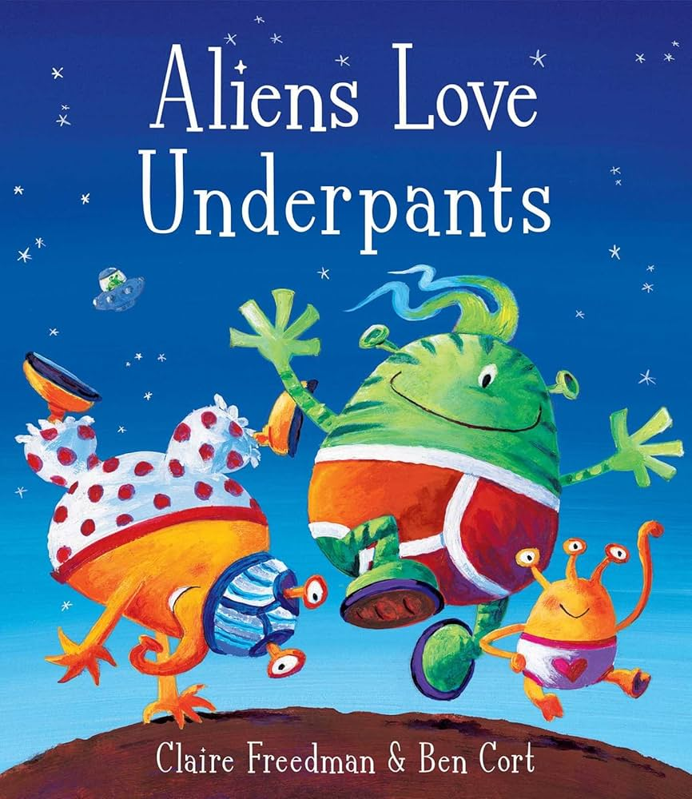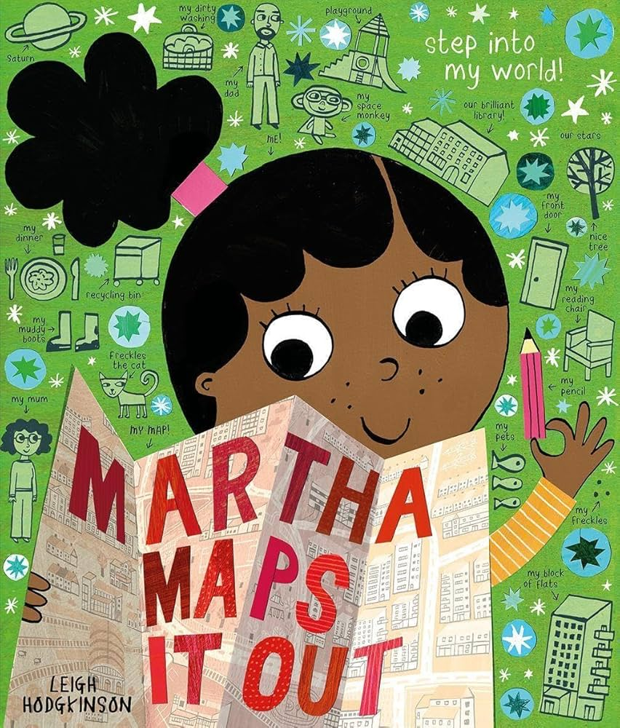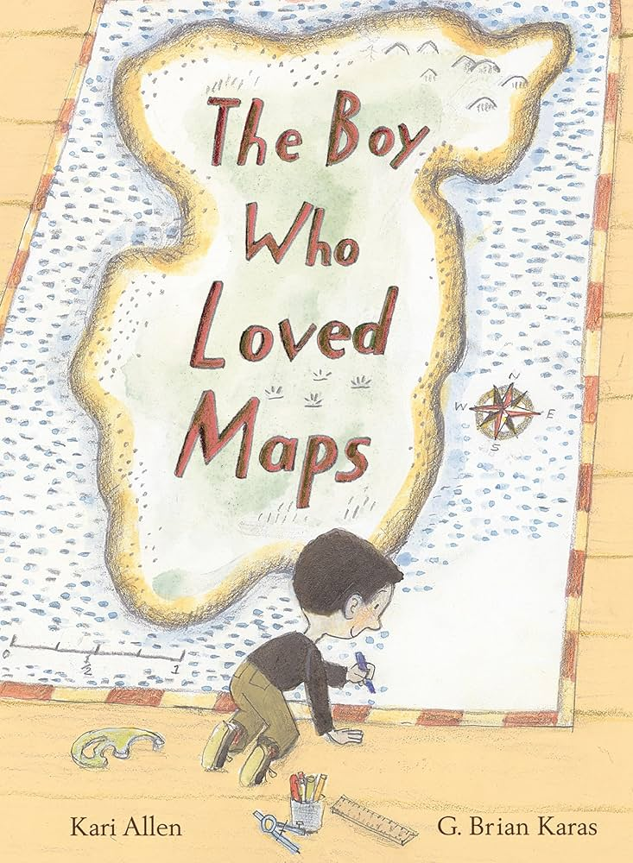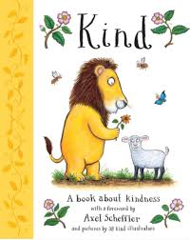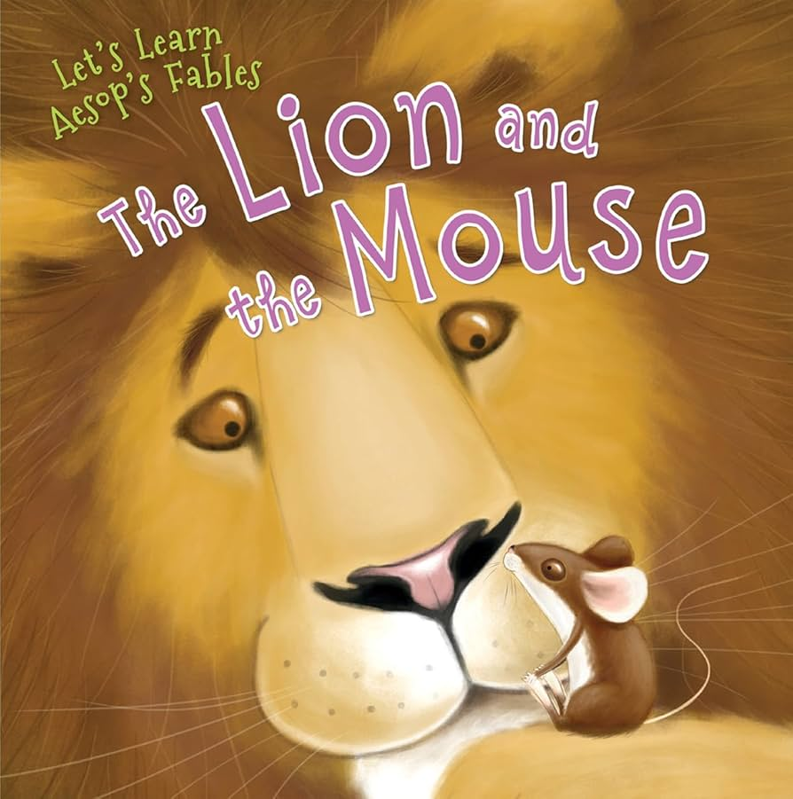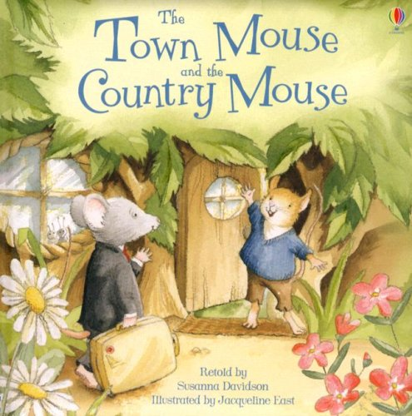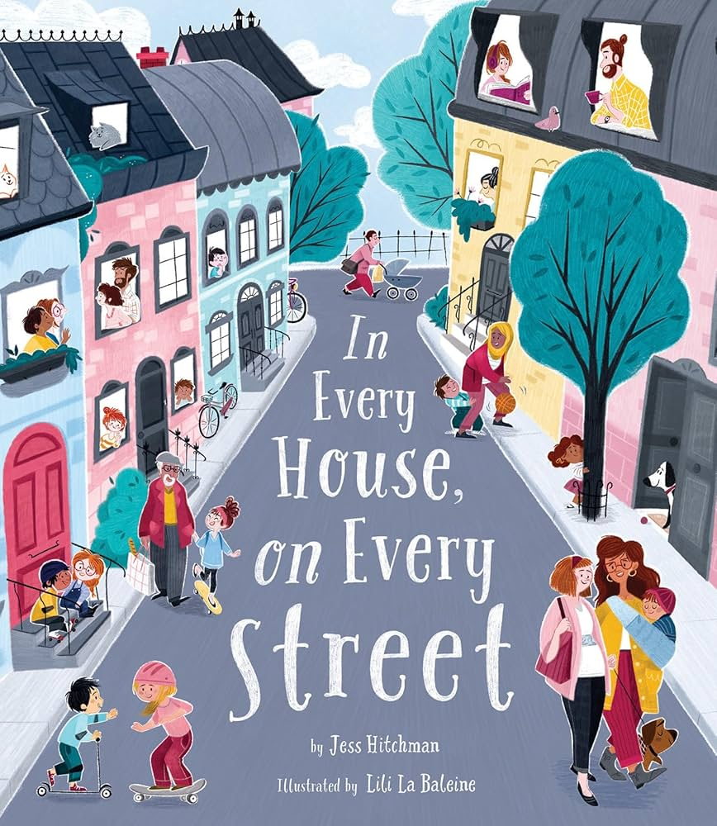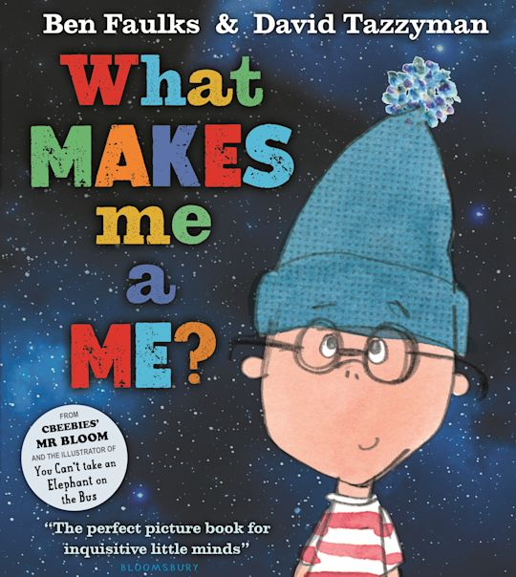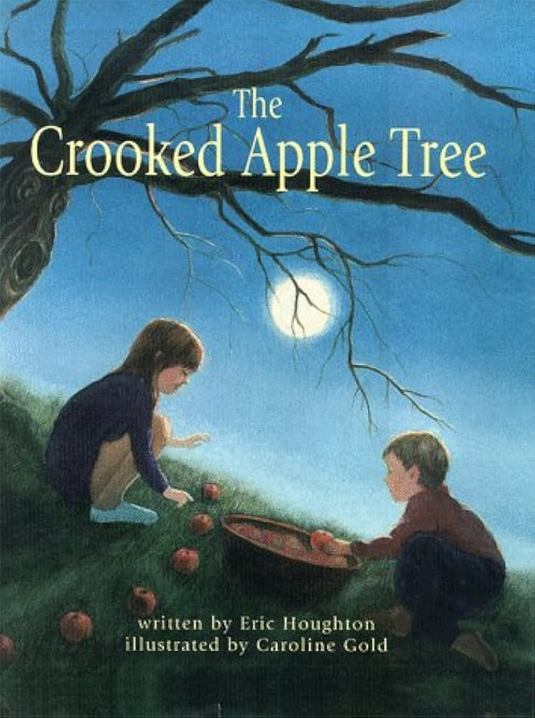
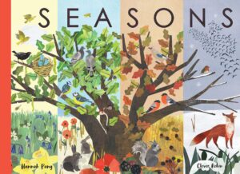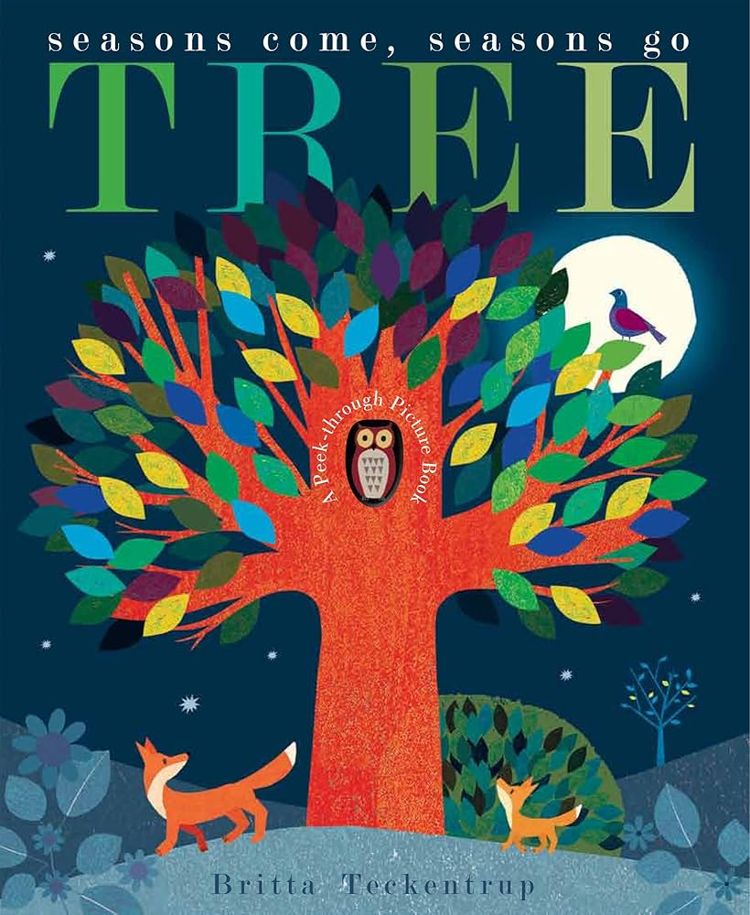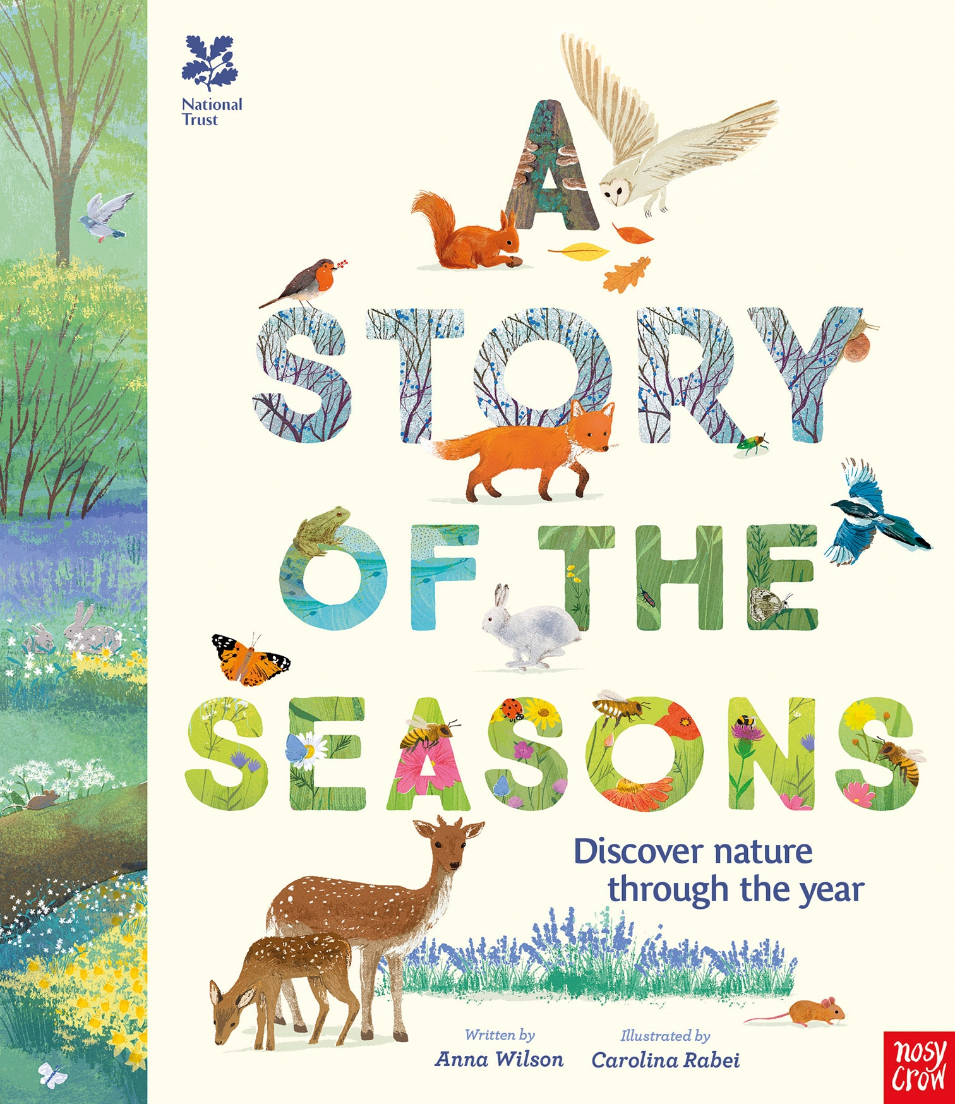
Wow Beginning:  Alien crash landing in the field! Alan was visiting planet Earth to collect underpants but his spaceship crash landed on our field. Now he will have to stay a while while we design him a new spacecraft. Will Alan like it here? | Celebration:  Take it in turns to take Alan home so that he can explore our community.  Display space rockets made by the children for Alan to go home in.  Powerpoint presentations about our school community.

The Learning Journey

SOCIETY: WHERE ARE WE IN PLACE AND TIME
Where do I live? Will Alan the Alien like it here?
Subject | Vocabulary | Lesson 1 | Lesson 2 | Lesson 3 | Lesson 4 | Lesson 5 | Lesson 6 | Assessment
Geography  Our Local Area | aerial photograph, aerial view, atlas, city, country, directional language, distance, features, globe, improve, key, land,locate, location, map, north, place, questionnaire, sea, survey, symbol, town, village | Where in the world are we?  Children locate the school grounds on an aerial photograph. | Where are the different places in our school?  Children create a simple map. | What can we find in our school grounds and how do we feel about our playground?  Children investigate key features of the playground. | Can we make our playground even better?  Children create a design to improve their playground. |  |  | Children design a map of their perfect playground at the beginning and end of the unit.  End of unit quiz.
Art | abstract, composition, curator, design, design brief, evaluate, felt, fibre, gallery, imaginary, inspired, landmarks, mosaic, overlap, pattern, shape, stained glass, texture, viewfinder | Creative Journey  Children investigate maps as a stimulus for drawing. | Relief Maps  Children develop their drawings into 3D artwork. | Abstract Maps  Children develop map drawings into stained=glass style artwork. | Print Possibilities  Children develop map drawings into simple print designs, making and using printing tiles. |  |  | Children evaluate their work against the design brief.  End of unit quiz.
Science/  Outdoor Explorers  Seasonal Change | deciduous tree, evergreen tree, seasons, weather, months of the year, temperature, thermometer, rainfall | Wonderful Weather  Children explore how the weather changes across the four seasons. | Seasonal Activities  Children identify events and activities that take place in different seasons. | How do Trees Change?  Children recognise how trees change across the four seasons. | Daylight Hours  Children record data in a pictogram to show how daylight hours change across the four seasons. | Observing Over Time  Children set up a weather station to gather and record data about how the weather changes during the four seasons. | Weather Reports  Children plan and carry out a weather report to add to their presentation about Clawton.  Link with Geography and ICT. | Knowledge Catcher.  Children draw a picture of the four seasons at the beginning and end of the unit.
Music  Tempo | beat, fast, singing voice, slow, speaking voice, warm up, tempo, perform | Snail and Louse  Children use voices and bodies expressively , while exploring tempo. | Exploring Rhyme with Snail and Mouse.  Children practise a rhyme using fast and slow beats on  instruments. | Singing Snail and Mouse.  Children use their voices to perform a song with a fast and slow beat. | Performing Snail and Mouse.  Children use singing voices and an instrument to perform a song with a fast and slow beat. | The Story of Snail and Mouse.  Children learn how to demonstrate fast and slow beats within the context of a story. |  | Music Quiz
ICT  Presentations | presentation, slides, image, format, insert, text box, reorder, folder, files, present | Presentation Skills: Folders  Children will learn/revise how to create a folder for their work. | Presentation Skills: What is a Presentation?  Children will identify the main features of a presentation. | Presentation Skills: New Slide and Slide Layout  Children will learn how to create slides in PowerPoint. | Presentation Skills: Add and Format an Image  Children will learn how to add an image to their presentation. | Presentation Skills: Reorder Slides and Present  Children will learn how to reorder the slides and present their work. |  | Assess presentation against Twinkl end of unit assessment statements.
PSHE  Being Different | similarities, differences, respect, emotions, feelings, relationships, diversity, tolerance, community, citizenship, cooperation, communication | What makes us who we are?  Children will recognise the importance of respecting others, even when they are different from them. | My Special People  Children will identify the people who are special to them. | How do we make others feel?  Children will recognise and explain how a person’s behaviour can affect other people. | When someone is feeling left out  Children will explain how it feels to be part of a group and explore strategies for helping someone who is feeling left out. | An Act of Kindness  Children will explore kind words and actions they can show to others. | Solve the Problem  Children will explore strategies for dealing with a range of common situations requiring negotiation skills to help foster and maintain positive relationships. | SCARF pre and post unit assessment.
PE  Invasion Games | travel, sidestep, control, direction, forwards, backwards, bounce, pass, turn, roll, push, invasion games | Controlling a Spaceship  Children will learn to travel backwards, sideways and forwards with control. They will also learn how to change direction. | Space Game: Roll an Asteroid  Children will learn how to travel with a ball in different ways. | Space Game: Watch out for the Craters!  Children will learn how to control a ball while travelling in different directions. | Space Game: Crater Dodge  Children will learn to change direction quickly (before they fall into a crater) while travelling with a ball. | Space Game: Hot Asteroids  Children will learn to pass the ball to another player. | Space Game: Space Invaders  Children will use travelling and passing skills in a game. | Follow the ‘All, Most, Some’ statements and success criteria on each Twinkl lesson plan.

